**SAP CONSUMABLES TESTING**

Objective:

Test the 3 CIMP produced files that the SAP group needs to maintain agent database and agent inventory.

Assumptions:

Test is performed by a Quality Engineer with understanding of how to log in as FST and perform consumable type transactions. Ability to perform CIMP executables on ESTE.

Prerequisites:

1. From the cimp/bin directory, run the cimp_pdfutil utility and select the option 3 - View product specific PDF parameters and verify the playslip ID for all the games is correct.
2. Also make sure the usage value available in the Ticket stock consumable type is accurate.
   * + 1. Consumable 1 type: Ticket Stock
       2. Count type: Line
       3. Usage: 0.1300
       4. Description: TICKET STOCK
       5. Details: (CARTONS OF 4 ROLLS)
3. All play slips that will be used by jurisdiction. Full rolls of appropriate Ticket stock.

|  |  |  |  |  |
| --- | --- | --- | --- | --- |
| **SAP Material #** | **Game Name** | **Product ID** | **Field ID** | **Hex** |
| MO-1001 | Ticket Stock | TS | 0 |  |
| MO-9101 | Powerball | 12 | 25600 | 0x6400 |
| MO-9105 | Show me cash | 10 | 33024 | 0x8100 |
| MO-9106 | Keno Bulls Eye | 15 | 61952 | 0xf200 |
| MO-9107-01 | Mega Millions | 13 | 126 | 0x7e |
| MO-9108 | Club Keno Multiplier | 15 | 31744 | 0x7c00 |
| MO-9109 | Double Keno Bulls Eye | 15 | 3840 | 0xf00 |
| MO-9110 | 1 Off | 16 | 98 | 0x62 |
| MO-9111 | Triple Play | 18 | 25 | 0x19 |
| MO-9112 | Lucky for Life | 14 | 218 | 0xda |
| MO-9102-01 | Lotto EZ Match | 11 | 118 | 0x76 |
| MO-9103-01 | Pick 3 EZ Match | 16 | 138 | 0x8a |
| MO-9104-01 | Pick 4 EZ Match | 17 | 82 | 0x52 |
| MO-9102 | Old Lotto | 11 | 30976 | 0x7900 |
| MO-9103 | Old Pick 3 | 16 | 19456 | 0x4c00 |
| MO-9104 | Old Pick 4 | 17 | 4352 | 0x1100 |

CIMP/SAP Testing

1. Test for Inventory/Delivery File

Prerequisites for Testing CIMP Files:

* Roll the system to a clean new CDC. This will ensure the file has “0” data for delivery and inventory.
* From the cimp/bin directory run the cimp_sap_invdel utility. This will generate an invdelXX_cdc.txt report under cimp/export directory.
* Name the report as invdelXX_cdc_beforetest.txt

1.1 Delivery File Test

* Sign on the terminal and sign on as FST.
* Perform the Delivery Test (Playslip Delivery and Ticket Stock Delivery)

Examples of ticket stock and play slip deliveries to be entered as an FST

Delivery of all consumable materials

Delivery of quantities over and under 10

Delivery of quantity over 99

Manually enter 1 carton of ticket stock

Scan 1 carton of ticket stock

1.2 Inventory File Test:

* Perform the Inventory File Test (Consumable inventory)
* Sign off the FST and then sign off the terminal.

Notes about inventory when entering:

* Do not populate any playslip or ticket stock with a ‘0’. Generally there will be an error message if ‘0’ is entered.
* If the retailer does not carry a particular play slip, the FST will enter an ‘88’ for the quantity
* An inventory must be performed on all consumable materials
* If there is no quantity entered at the terminal, the host translates it to an ‘88’ before passing to SAP. In SAP this will block that material from order replenishment.

After Test Reports:

* From the cimp/bin directory run the cimp_sap_invdel utility. This will generate an invdelXX_cdc.txt report under cimp/export directory.
* Name the report as invdelXX_cdc_aftertest.txt

Example of invdelXX_cdc_aftertest.txt Report:

NC|20131130|061447|4567|110000|1|TS||SD|AB1234567|0| Delivery

NC|20131130|061619|4567|110000|1|12|52736|SD||10|

NC|20131130|061619|4567|110000|1|11|59392|SD||20|

NC|20131130|061619|4567|110000|1|16|14336|SD||30|

NC|20131130|061619|4567|110000|1|10|37889|SD||40|

NC|20131130|061619|4567|110000|1|14|10241|SD||50|

NC|20131130|061721|4567|110000|1|TS||IN||99| Inventory

NC|20131130|061721|4567|110000|1|12|52736|IN||11|

NC|20131130|061721|4567|110000|1|11|59392|IN||12|

NC|20131130|061721|4567|110000|1|16|14336|IN||13|

NC|20131130|061721|4567|110000|1|10|37889|IN||14|

NC|20131130|061721|4567|110000|1|14|10241|IN||15|

NOTE: Always perform Delivery Test First and then the Inventory Test.

1.3 Email the files to SAP group the before and after file along with either copies of the receipts from the FST performing the delivery and inventory or a document listing what amounts were entered for delivery and inventory.

2. Ticket Stock Usage Test

Prerequisites:

* Complete play slips for all wager types for all games that use play slips (include any Add-on, EZMatch, Power play or Mega play wagers specific to the jurisdiction).
* A different quantity of play slips should be used for each game. MAKE SURE YOU RUN THESE PLAYSLIPS THOUGH A TERMINAL TO INSURE NO ERROR MESSAGES ARE RECEIVED BEFORE ACTUAL TEST. If an error message is received during the usage test it must be reported in the excel spreadsheet.

2.1 Sample Usage Test

2.1.1 Before Test Reports:

Once all of the slips have been filled out there are two test options:

Option 1:

* Sign on terminals and roll the day (leave the terminal signed on). Once the day roll is complete verify the usage report is empty by executing cimp_sap_usage in the cimp/bin for current CDC (note previous CDC is the default).
* View the supplyXX_cdc.txt report in the cimp/export directory. The report should be empty.
* Name the report as supplyXX_cdc_beforetest.txt

20160524|WA|100282|TS|0|11|**0**|0| *This is the Ticket Stock usage number to monitor

20160524|WA|100282|11|224|11|0|0|

20160524|WA|100282|19|42|11|0|0|

20160524|WA|100282|15|190|11|0|0|

20160524|WA|100282|16|48|11|0|0|

20160524|WA|100282|23|182|11|0|0|

20160524|WA|100282|13|9|11|0|0|

20160524|WA|100282|20|166|11|0|0|

20160524|WA|100282|20|53249|11|0|0|

Option 2:

* Starting in middle of a CDC with transactions already performed on the terminal.
* Sign on, sign off and sign on again.
* Execute cimp_sap_usage in the cimp/bin for current CDC (note previous CDC is the default).
* Save a copy of the report *supplyXX_cdc_beforetest.txt*

20160524|WA|290012|TS|0|11|**1402**|0| *This is the Ticket Stock usage number to monitor

20160524|WA|290012|11|224|11|0|0|

20160524|WA|290012|19|42|11|0|0|

20160524|WA|290012|15|190|11|0|0|

20160524|WA|290012|16|48|11|0|0|

20160524|WA|290012|23|182|11|0|0|

20160524|WA|290012|13|9|11|0|0|

20160524|WA|290012|20|166|11|0|0|

20160524|WA|290012|20|53249|11|0|0|

2.1.3 Sample usage Test:

* Place wagers for all of the games using the play slips.
* Save your tickets.
* Once all of the wager transactions for that terminal type are complete sign off and sign on the terminal.
* Execute cimp_sap_usage and save a copy of the supply usage report *supplyXX_cdc_aftertest.txt.*
* Measure each wager individually to the 1/8th inch and add the data to the Usage Test excel spread sheet. Enter length by decimal ie. 1/8th = 0.125, 2/8th = 0.25, 3/8th = 0.325 etc.
* These steps need to be performed for each terminal type for the jurisdiction.
* If the jurisdiction breaks down the usage by terminal add columns to accommodate for each terminal belonging to a retailer.
* If test option 2 is being used the usage amount will need to be calculated:

*supplyXX_cdc_beforetest.txt*

20160524|WA|290012|TS|0|11|**1402**|0|

*supplyXX_cdc_aftertest.txt*

20160524|WA|290012|TS|0|11|**3445**|0|

3445 – 1402 = 2043

2043 is the amount entered for line item *‘File usage value sent to SAP from host file’* on the usage spreadsheet

Example of the Sample usage Spreadsheet:

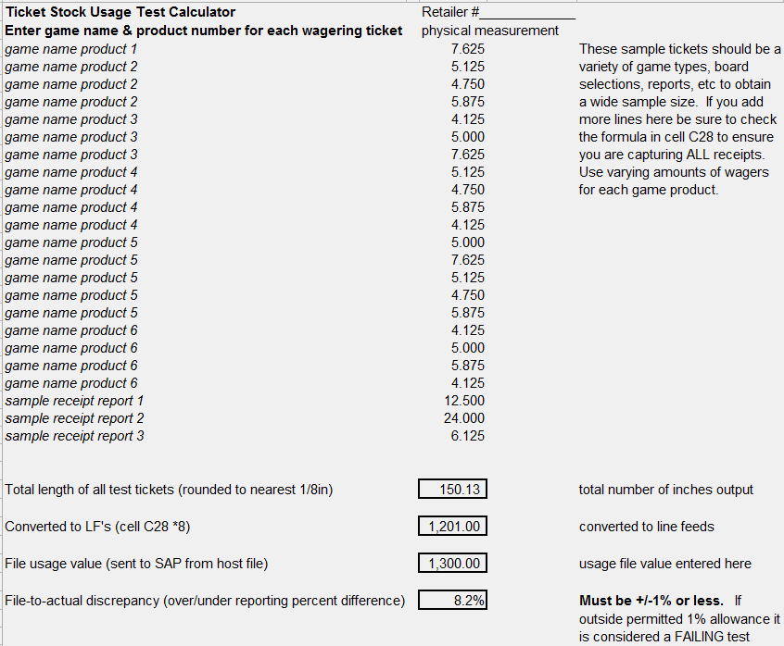

LF = line feeds. The total inches are then converted into line feeds. (Cell28*8)

**The discrepancy must be +/-1% or less. If outside permitted 1% allowance it is considered a FAILING test. A TIR should be written including the before and after files from ESTE, usage spreadsheet and gsrv tmir.

2.1.4 Email to the SAP group the before and after files along with the usage spreadsheet

filled out with test results. Only email these test artifacts when the sample test is

within the +/- 1% range.

2.2 FULL PAPER ROLL TESTING

Prerequisites:

1. Sample Ticket Stock usage test has passed according to the SAP group.
2. Have the appropriate site specific full paper roll.

Option 1:

Begin test after dayend

* Roll to the clear day.
* Execute *cimp/bin cimp_sap_usage* use current CDC
* Name the report as *supplyXX_Before_cdc.txt*
* Sign on the terminal.
* Insert new paper roll

Option 2:

Begin test after some transactions have been placed during a CDC

* Sign off the terminal
* Sign on the terminal
* Execute *cimp/bin cimp_sap_usage* use current CDC
* Name the report as *supplyXX_Before_cdc.txt*
* Insert new paper roll

Full Paper Roll Test steps:

* Place wagers for complete paper of roll.
* Terminal displays ‘Printer Low on Paper Please change the paper roll’ Message.
* Keep placing the wagers until the roll is empty.
* Terminal displays ‘Printer out of Paper Please change the paper roll’ Message.
* Measure and include in report to the SAP group the waste produced during test.
* Insert a paper roll.
* Sign off and sign on the terminal.
* Execute *cimp/bin cimp_sap_usage* use current CDC.
* Name the report as supplyXX_After_cdc.txt.

2.2.1 Email the before and after test files along with the measurements of any waste produced during the full roll test.

3. Playslip Usage Test

Prerequisites

* Have on hand each of the playslips used for all games
* Use a different count of playslip usage for each game for the test

Option 1:

Begin test after dayend

* Roll to the clear day.
* Execute *cimp/bin cimp_sap_usage* use current CDC
* Name the report as *supplyXX_Before_cdc.txt*
* Sign on the terminal.

Option 2:

Begin test after some transactions have been placed during a CDC

* Sign off the terminal
* Sign on the terminal
* Execute *cimp/bin cimp_sap_usage* use current CDC
* Name the report as *supplyXX_Before_cdc.txt*

3.1 Execute test

* Place wagers for all of the games using the play slips.
* Save your tickets.
* Once all of the wager transactions for that terminal type are complete sign off and sign on the terminal.
* Execute cimp_sap_usage and save a copy of the supply usage report *supplyXX_cdc_aftertest.txt.*
* Enter the playslip usage into the TS Usage_test with calcs2xlsx.xlsx spreadsheet
* If the jurisdiction breaks down the usage by terminal add columns to accommodate for each terminal belonging to a retailer.

Sample of TS Usage test with calcs2xlsx.xlsx for playslip usage.

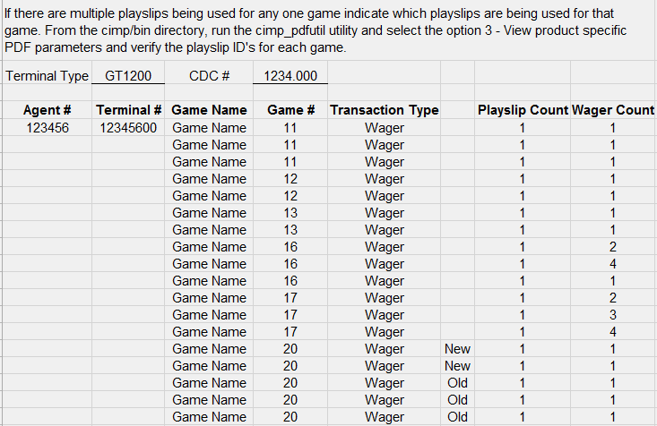

3.1.1 Email the before and after test files along with the filled out usage spreadsheet to the SAP group.

4. Agent Test File

* The agent add, modify and change ownership agent file should contain an indicator for Add (A) Change of Ownership (C), or Modification (M).
* The file should contain the following:

File name: agentXX.txt the last two digits of file represents lottery jurisdiction

File provided in ASCII format

Fields to be delineated with ‘|’ (pipe) symbol.

Empty or null fields should be compressed.

Likewise, leading spaces and/or zeroes in numeric represented data should be compressed to minimize disk space requirements.

Fields:

New/Change Code 1 alphanumeric (A=add/new, C=change of ownership, M = modification)

Date 8 YYYYMMDD

Retailer/Agent # (equipment specific) numeric (How many digits depends on jurisdiction)

Retailer/Agent # (collective retail location) numeric (How many digits depends on jurisdiction)

Lottery Code (jurisdiction) 3 alphanumeric i.e. Value ‘OR’

*quantity depends on jurisdiction

Hardware ID 3 numeric (code to differentiate terminal type)

*quantity depends on jurisdiction

Name 35 alphanumeric

Shipping Address1 35 alphanumeric

Shipping Address2 35 alphanumeric

Shipping Address3 35 alphanumeric

City 25 alphanumeric

Zip Code 9 alphanumeric (no formatting ‘123450000’)

State 2 alphanumeric

Phone Number 16 alphanumeric

Agent Status (3 - inactive / 1 - active) 1 numeric

Old Agent # (for CHOW records) numeric (How many digits depends on jurisdiction)

District Code alphanumeric

(How many digits depends on jurisdiction)

Max Record Length: 162 bytes

Average record length will be less because of data compression

* When creating the data ensure to add an agent, modify the address, phone etc of another agent, and perform a change of ownership on an agent. TIP – ESTE and ESRM need to be on same date when performing this test. ESRM date/time is the physical time NOT ESTE date/time.

Sample Agent File layout:

A|20160517|290022|290022|WA|11|testing cimp2|345 Boren Ave|||N Seattle|98109|WA|2062661000|3||0000|

C|20160517|290023|290023|WA|11|testing cimp2|345 Boren Ave|||N Seattle|98109|WA|2062661000|1|290022|0000|

M|20160517|290033|290033|WA|11|Prenote test|2345 main|||MEDICAL LAKE|99022|WA|4013921000|1||0000|

NOTES:

* Address information is taken from the shipping address fields in retailer management.
* File to be sorted by Adds -A, Chows –C, and Modifications –M.
* The Old Agent # (used within Chow records) is not populated within non-Chow records.
* Equipment / Hardware codes may be uniquely defined within each jurisdiction. Codes are to represent how hardware / terminals are defined within a IGT site.
* The District Code is an optional field